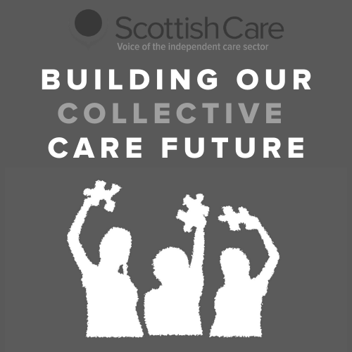

Welcome

Collective Care Futures Programme - Profile Survey

Thank you for your interest in the Care Futures programme. This is the final of 6 weekly surveys in Phase 1.

This first phase of the programme is focused on understanding the pandemic experience given the significant changes and impacts across many different areas of practice both in care homes and care at home.

If you have experience of working or connecting with care homes or care at home services we invite you to take part in this survey series to share your experience.

The final survey is focused on the theme of ‘Profile’. In this theme we are interested to explore perceptions of the independent social care sector during the pandemic, relationships with the media, opportunities for enhancing understanding, awareness and profile and the future potential of the sector in relation to its profile.
The survey has 4 sections: Perception, understanding & awareness; Value & recognition; Media, publicity & scrutiny; and Future profile.
If you would like to see the questions in advance to help you complete the survey fully, you can download a PDF of the survey here - download survey questions.

You can also download Word copies of the survey to complete by hand or to distribute to others - download Word survey questions.

Please send any completed survey responses to carefutures@scottishcare.org

Each week we will share a survey based on the weekly theme topic we are exploring. Each survey will take approximately 20-25 minutes to complete and there will be 6 surveys in total over the 6 weeks. You can choose to take part in as many or as little as you wish.

You can access previous surveys at: http://www.scottishcare.org/care-futures-surveys/

If you don’t feel that you have had direct working experience with the independent care sector during the pandemic but you would like to be involved in the second phase of the programme, please let us know and we will be in contact in due course.

About you

Collective Care Futures Programme - Profile Survey
This section is strictly confidential. No information from this section will be shared or attributed to your responses.

1. Your name

2. Your organisation/service (if applicable)

- 3. Contact email address

  - 4. I am happy to be contacted to provide further information based on my responses
Yes No

5. I would like to be contacted regarding updates and further opportunities to be involved around the Collective Care Future programme
Yes No

Respondent information

Collective Care Futures Programme - Profile Survey

This rest of your responses will be collected and analysed. Any quotes or information used in future write ups will be anonymised.

6. I am completing the survey from the perspective/context of:
Care home service Homecare service
Health & Social Care Partnership Local Authority
NHS/Health Board
Third Sector organisation (please specify) Charitable body (please specify)
Unpaid carer
Person who accesses social care support
Relative/friend of person who accesses social care support Other (please specify)

Your role (if applicable):

  - 8. Location:
Scotland-wide Aberdeen City Aberdeenshire Angus
Argyll & Bute City of Edinburgh

Clackmannanshire
Comhairle nan Eilean Siar Dumfries & Galloway
Dundee City East Ayrshire
East Dunbartonshire East Lothian
East Renfrewshire Falkirk
Fife
Glasgow City Highland
Inverclyde Midlothian Moray
North Ayrshire North Lanarkshire Orkney Islands Perth & Kinross Renfrewshire
Scottish Borders Shetland Islands South Ayrshire South Lanarkshire Stirling
West Dunbartonshire West Lothian
Other (please specify)

Service information

Collective Care Futures Programme - Profile Survey

Please skip to the next page if you do not work in a care home or homecare service

Sector:
Private
Voluntary - charitable/not for profit Statutory

Type of service:
Care home for adults

Care home with nursing for adults Care at home service
Housing support service

Specialist service (please specify below)

Other (please specify)

Size of service (care homes)
1 - 10 beds
11- 20 beds
21 - 30
31 - 40 beds
41 - 50 beds
51 - 60 beds
More than 60 beds

If you work across/operate a number of services, please specify both number of services and total number of beds

Size of service - homecare weekly hours
Up to 1000 hours 1000-2000 hours
2000-5000 hours
5000-10,000 hours
More than 10,000 hours

If you work across/operate a number of services, please specify both number of services and total hours

Perception, understanding and awareness

Collective Care Futures Programme - Profile Survey

  - How would you describe the profile of the independent social care sector during the pandemic?

  - In what ways has the pandemic experience impacted on people's perception of the independent social care sector?

  - From your experience, have there been any specific changes in people's understanding or awareness of different parts of the sector during the pandemic? Please answer all that apply.

Care homes

Homecare services

Workforce (please specify any particular roles or settings)

Other (please specify)

  - How has people's level of understanding of the sector been affected as a result of the pandemic?
What is better understood?

Why, and for who?

What is less/not understood?

Why, and for who?

Value and recognition

Collective Care Futures Programme - Profile Survey

How has the pandemic experience impacted the value placed on the independent social care sector?
What has been valued, and by who?
What has been undervalued, and by who?

  - What is your experience or awareness of recognition in the part of the sector that applies to you? Please provide any specific examples

  - What, in your view, are the biggest factors affecting value and recognition of the sector?

Media, publicity and scrutiny

Collective Care Futures Programme - Profile Survey

  - How would you describe the relationship between the media and the independent social care sector during the pandemic?
Very positive Positive
Neutral Negative
Very negative

Please describe the reasons for your response, including any experience you have had of engaging with the media

  - What individuals, groups or organisations have played a role in the sector's profile and publicity during the pandemic? Please describe what impact they have had

Individuals

Groups

Organisations

Other

  - What initiatives, campaigns or public messages have impacted the profile of the sector during the pandemic? Please explain the nature of the impact.

  - How would you describe the experience of scrutiny of the sector during the pandemic?
What has been helpful/supportive
What has been unhelpful/challenging

Future profile

Collective Care Futures Programme - Profile Survey

What has surprised you about the profile of the sector during the pandemic?

  - Has the pandemic experience impacted your own view or role in relation to shaping the profile of the sector? If so, in what way?

What needs to change in relation to the profile of the sector?

  - What actions would you like to see prioritised in relation to profile of the sector going forward? Please specify who and what is required to achieve this.

  - Please share a word or phrase to sum up how you would describe the profile of the independent social care sector:
I would describe the current profile as:
I would like the future profile to be described as:

This will require:

Thank You

Collective Care Futures Programme - Profile Survey

We are really grateful for you taking the time to complete this survey. We hope you have found it a useful way of sharing your COVID-19 experiences around profile.

This is the final survey in Phase 1 of the Collective Care Future programme.

However, you can still access previous surveys at: https://scottishcare.org/project/collective-care-future/. You would be most welcome to participate in these too and your contribution would be valued. The surveys will remain open until September 2020.

Please share the surveys across your networks to ensure a wide range of experiences are represented. This includes frontline staff, people who access support and their loved ones.

The insights you share will be included (anonymously) in a written report that will be made available on the Scottish Care website. We may also present the programme findings at conferences and share updates of the programme on social media. No personal identifiable information (e.g. your name) will be used in any publication.

The survey responses will also be used to inform the second phase of the programme to shape more 'future focused' themes around what social care could and should look like. In this second phase of the programme we will undertake further engagement around the future of the independent care sector. If you would like to contribute in the second phase, please let us know on the details below. Further information on the second phase will also be provided on the Scottish Care website https://scottishcare.org/project/collective-care-future/

If you would like to discuss anything further related to the programme and your involvement, please contact: Becca Young, Policy & Research Manager | becca.young@scottishcare.org
Dr Tara French, Technology & Innovation Lead | tara.french@scottishcare.org

