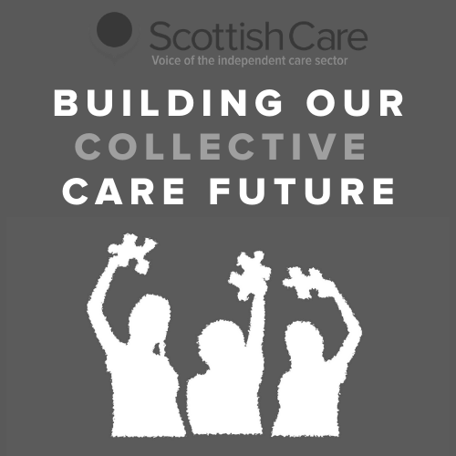

Welcome

Collective Care Futures Programme - Wellbeing Survey

Thank you for your interest in the Care Futures programme.

This first phase of the programme is focused on understanding the pandemic experience given the significant changes and impacts across many different areas of practice both in care homes and care at home.

If you have experience of working or connecting with care homes or care at home services we invite you to take part in this survey series to share your experience.

This week the survey is focused on the theme of ‘Wellbeing’. In this theme we are interested to explore the impacts of COVID-19 on wellbeing for staff, residents, families and people supported as well as the forms, use and value of wellbeing supports.

The survey has 3 sections: Wellbeing impacts, Forms of support, and Future wellbeing.
If you would like to see the questions in advance to help you complete the survey fully, you can download a PDF of the survey here - download survey questions.

You can also download Word copies of the survey to complete by hand or to distribute to others - download Word survey questions.

Please send any completed survey responses to carefutures@scottishcare.org

Each week we will share a survey based on the weekly theme topic we are exploring. Each survey will take approximately 20-25 minutes to complete and there will be 6 surveys in total over the 6 weeks. You can choose to take part in as many or as little as you wish.

You can access previous surveys at: http://www.scottishcare.org/care-futures-surveys/

If you don’t feel that you have had direct working experience with the independent care sector during the pandemic but you would like to be involved in the second phase of the programme, please let us know and we will be in contact in due course.

About you

Collective Care Futures Programme - Wellbeing Survey
This section is strictly confidential. No information from this section will be shared or attributed to your responses.

1. Your name

2. Your organisation/service (if applicable)

- 3. Contact email address

  - 4. I am happy to be contacted to provide further information based on my responses
Yes No

5. I would like to be contacted regarding updates and further opportunities to be involved around the Collective Care Future programme
Yes No

Respondent information

Collective Care Futures Programme - Wellbeing Survey

This rest of your responses will be collected and analysed. Any quotes or information used in future write ups will be anonymised.

6. I am completing the survey from the perspective/context of:
Care home service Homecare service
Health & Social Care Partnership Local Authority
NHS/Health Board
Third Sector organisation (please specify) Charitable body (please specify)
Unpaid carer
Person who accesses social care support
Relative/friend of person who accesses social care support Other (please specify)

Your role (if applicable):

  - 8. Location:
Scotland-wide Aberdeen City Aberdeenshire Angus
Argyll & Bute City of Edinburgh

Clackmannanshire
Comhairle nan Eilean Siar Dumfries & Galloway
Dundee City East Ayrshire
East Dunbartonshire East Lothian
East Renfrewshire Falkirk
Fife
Glasgow City Highland
Inverclyde Midlothian Moray
North Ayrshire North Lanarkshire Orkney Islands Perth & Kinross Renfrewshire
Scottish Borders Shetland Islands South Ayrshire South Lanarkshire Stirling
West Dunbartonshire West Lothian
Other (please specify)

Service information

Collective Care Futures Programme - Wellbeing Survey

Please skip to the next page if you do not work in a care home or homecare service

Sector:
Private
Voluntary - charitable/not for profit Statutory

Type of service:
Care home for adults

Care home with nursing for adults Care at home service
Housing support service

Specialist service (please specify below)

Other (please specify)

Size of service (care homes)
1 - 10 beds
11- 20 beds
21 - 30
31 - 40 beds
41 - 50 beds
51 - 60 beds
More than 60 beds

If you work across/operate a number of services, please specify both number of services and total number of beds

Size of service - homecare weekly hours
Up to 1000 hours 1000-2000 hours
2000-5000 hours
5000-10,000 hours
More than 10,000 hours

If you work across/operate a number of services, please specify both number of services and total hours

Wellbeing impacts

Collective Care Futures Programme - Wellbeing Survey

  - What does wellbeing mean to you in the context of social care?

How would you describe the impact of the pandemic on wellbeing across the care home/care at home sector?

  - From your experience, can you describe the impact of COVID-19 on wellbeing for specific groups? Please answer all that apply.

Care home staff

Care at home staff

Supervisors and managers

Care home residents

People supported at home

Families and loved ones

Others (please specify)

Based on your responses, what do you feel have been the biggest differences in your experience of wellbeing during COVID-19?

  - What factors have influenced wellbeing during COVID-19, and for who?

Positive influences

Negative influences

Forms of support

Collective Care Futures Programme - Wellbeing Survey

  - From your experience, what forms of wellbeing support are you aware of for specific groups? Please answer all that apply.

Care home staff

Care at home staff

Supervisors and managers

Care home residents

People supported at home

Families and loved ones

Others (please specify)

If you have accessed any forms of wellbeing support (for yourself or others), can you describe your experience of this? Please specify what support(s) you accessed.
e.g. Was this support useful/helpful? Was it easy to access? Was it tailored to your needs?

  - Who or what has been most valuable in terms of supporting wellbeing during COVID-19?

For yourself

For others (please specify who)

  - Has anything been challenging or missing in terms of forms of wellbeing support during COVID-19?

Future wellbeing

Collective Care Futures Programme - Wellbeing Survey

What has surprised you about the experience of wellbeing during COVID-19?

  - What would you want to see more of for wellbeing across the social care sector?

What needs to change in relation to wellbeing across the social care sector?

  - What would you like to see prioritised in relation to wellbeing across the social care sector going forward?

Thank You

Collective Care Futures Programme - Wellbeing Survey

We are really grateful for you taking the time to complete this survey. We hope you have found it a useful way of sharing your COVID-19 experiences around wellbeing.

If you would like support around your own wellbeing or that of others, the following resources may be useful :

Promis.Scot website (national wellbeing hub for people working in health and social care) - https://www.promis.scot/
Health and social care workforce mental wellbeing support line (available 24/7) - 0800 111 4191 Breathing Space website https://breathingspace.scot/ and helpline - 0800 83 85 87
Age Scotland helpline for older people, carers and families - 0800 12 44222
Support Around Death (COVID-19 bereavement resources) - http://www.sad.scot.nhs.uk/covid-19/

The insights you share will be included (anonymously) in a written report that will be made available on the Scottish Care website. We may also present the programme findings at conferences and share updates of the programme on social media. No personal identifiable information (e.g. your name) will be used in any publication.

The survey responses will also be used to inform the second phase of the programme to shape more 'future focused' themes around what social care could and should look like. In this second phase of the programme we will undertake further engagement around the future of the independent care sector. If you would like to contribute in the second phase, please let us know on the details below. Further information on the second phase will also be provided on the Scottish Care website https://scottishcare.org/project/collective-care-future/

The final survey, which focuses on Profile of the social care sector, will be shared next week.

You can access previous surveys at: https://scottishcare.org/project/collective-care-future/ You would be most welcome to participate in these too and your contribution would be valued.

If you would like to discuss anything further related to the programme and your involvement, please contact: Becca Young, Policy & Research Manager | becca.young@scottishcare.org
Dr Tara French, Technology & Innovation Lead | tara.french@scottishcare.org

