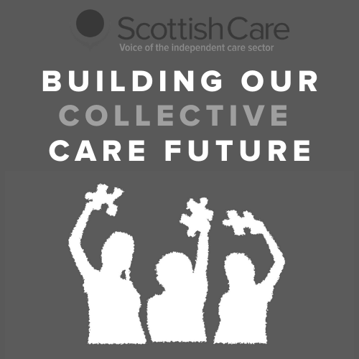

Welcome

Collective Care Futures Programme - Care Practice Survey

Thank you for your interest in the Care Futures programme.

This first phase of the programme is focused on understanding the pandemic experience given the significant changes and impacts across many different areas of practice both in care homes and care at home.

If you have experience of working or connecting with care homes or care at home services we invite you to take part in this survey series to share your experience.

This week the survey is focused on the theme of ‘Care Practice’. In this theme we are interested to explore the ways in which the delivery of care and support has changed, across areas such as dementia, palliative and end of life care, assessment and care planning. It includes ways of delivering care which you may have adopted or been aware of previously and those which you have experienced for the first time during the pandemic.

The survey has 4 sections: Impact on Care Practice, Regulation & Guidance, Outcomes & Priorities, and Future Care Practice.

f you would like to see the questions in advance to help you complete the survey fully, you can download a PDF of the survey here - download survey questions.

You can also download Word copies of the survey to complete by hand or to distribute to others - download Word survey questions.

Please send any completed survey responses to carefutures@scottishcare.org

Each week we will share a survey based on the weekly theme topic we are exploring. Each survey will take approximately 20-25 minutes to complete and there will be 6 surveys in total over the 6 weeks. You can choose to take part in as many or as little as you wish.

You can access previous surveys at: https://scottishcare.org/project/collective-care-future/

If you don’t feel that you have had direct working experience with the independent care sector during the pandemic but you would like to be involved in the second phase of the programme, please let us know and we will be in contact in due course.

About You

Collective Care Futures Programme - Care Practice Survey
This section is strictly confidential. No information from this section will be shared or attributed to your responses.

1. Your name

2. Your organisation/service (if applicable)

- 3. Contact email address

  - 4. I am happy to be contacted to provide further information based on my responses
Yes No

5. I would like to be contacted regarding updates and further opportunities to be involved around the Collective Care Future programme
Yes No

Respondent information

Collective Care Futures Programme - Care Practice Survey

This rest of your responses will be collected and analysed. Any quotes or information used in future write ups will be anonymised.

6. I am completing the survey from the perspective/context of:
Care home service Homecare service
Health & Social Care Partnership Local Authority
NHS/Health Board
Third Sector organisation (please specify) Charitable body (please specify)
Unpaid carer
Person who accesses social care support
Relative/friend of person who accesses social care support Other (please specify)

Your role (if applicable):

  - 8. Location:
Scotland-wide Aberdeen City Aberdeenshire Angus
Argyll & Bute City of Edinburgh

Clackmannanshire
Comhairle nan Eilean Siar Dumfries & Galloway
Dundee City East Ayrshire
East Dunbartonshire East Lothian
East Renfrewshire Falkirk
Fife
Glasgow City Highland
Inverclyde Midlothian Moray
North Ayrshire North Lanarkshire Orkney Islands Perth & Kinross Renfrewshire
Scottish Borders Shetland Islands South Ayrshire South Lanarkshire Stirling
West Dunbartonshire West Lothian
Other (please specify)

Service Information

Collective Care Futures Programme - Care Practice Survey

Please skip to the next page if you do not work in a care home or homecare service

Sector:
Private
Voluntary - charitable/not for profit Statutory

Type of service:
Care home for adults

Care home with nursing for adults Care at home service
Housing support service

Specialist service (please specify below)

Other (please specify)

Size of service (care homes)
1 - 10 beds
11- 20 beds
21 - 30
31 - 40 beds
41 - 50 beds
51 - 60 beds
More than 60 beds

If you work across/operate a number of services, please specify both number of services and total number of beds

Size of service - homecare weekly hours
Up to 1000 hours 1000-2000 hours
2000-5000 hours
5000-10,000 hours
More than 10,000 hours

If you work across/operate a number of services, please specify both number of services and total hours

Impact on Care Practice

Collective Care Futures Programme - Care Practice Survey

How would you describe the impact of COVID-19 on the way that care is delivered in your setting (e.g. care home, care at home)?

  - In your experience, what areas of care practice have been impacted during COVID-19 and how? Please answer as many as apply and include any additional areas.

Dementia

Palliative and end of life care

Workforce planning

Assessment

Care planning, monitoring & recording
Admission/ access to services

Person-centred care

Medication management

Communication

Care routines (care home daily structure/ care at home visits, etc)

Other (please specify)

Based on your responses, what do you feel have been the biggest changes in how care is delivered in your setting?

Regulation and Guidance

Collective Care Futures Programme - Care Practice Survey

  - How would you describe your experience of service regulation during COVID-19?

  - Please provide details of what aspects of regulation have changed during COVID-19 and how these have been experienced:
What changes have worked well
What changes have been challenging

How would you describe your experience of care practice guidance during COVID-19?

  - Please provide further comments on your experience of receiving and using guidance during COVID- 19:

Accessing

Interpreting

Applying

Updating

Please provide any additional information you would like to share related to your experience of regulation and/or guidance:

Outcomes and Priorities

Collective Care Futures Programme - Care Practice Survey

  - Have there been any new care practices/ways of delivering care that you would like to continue in the future?

  - Have there been any new or different ways of regulating care that you would like to continue in the future?

What areas of changed care practice have been most valuable in social care during COVID-19 and
for who?

Future Care Practice

Collective Care Futures Programme - Care Practice Survey

  - What has surprised you about delivering/accessing care in your setting during COVID-19?

  - What would you want others to know about the way social care has been delivered during COVID- 19?

What do you think the priorities for care practice in your setting should be going forward?

Thank You

Collective Care Futures Programme - Care Practice Survey

We are really grateful for you taking the time to complete this survey. We hope you have found it a useful way of sharing your COVID-19 experiences around care practice.

The insights you share will be included (anonymously) in a written report that will be made available on the Scottish Care website. We may also present the programme findings at conferences and share updates of the programme on social media. No personal identifiable information (e.g. your name) will be used in any publication.

The survey responses will also be used to inform the second phase of the programme to shape more 'future focused' themes around what social care could and should look like. In this second phase of the programme we will undertake further engagement around the future of the independent care sector. If you would like to contribute in the second phase, please let us know on the details below. Further information on the second phase will also be provided on the Scottish Care website https://scottishcare.org/project/collective-care-future/

We will be sharing surveys on other themes on a weekly basis over the next 4 weeks. You would be most welcome to participate in these too and your contribution would be valued.

You can access previous surveys at: https://scottishcare.org/project/collective-care-future/

If you would like to discuss anything further related to the programme and your involvement, please contact: Becca Young, Policy & Research Manager | becca.young@scottishcare.org
Dr Tara French, Technology & Innovation Lead | tara.french@scottishcare.org

