**Care homes and carers – useful information from NHS 24 during COVID-19**

Contents

Self help guides 1

NHS24:Covid-19 app 2

Calling 111 3

Accessible information 3

Anticipatory Care Planning (ACPs) 3

Registration of a death 4

Wellbeing for carers, families and friends 4

Further resources 4

## Self help guides

**Coronavirus/COVID-19** – Find out more about symptoms, when you can use self-care, and what to do if someone's condition worsens and you need medical help.

[https://www.NHSinform.scot/self-help-guides/self-help-guide-coronavirus-covid-19](https://www.nhsinform.scot/self-help-guides/self-help-guide-coronavirus-covid-19)

**Other conditions** - If you need to care for yourself or someone else and you are not sure what to do, you could start with self-help guides from NHS inform. They are an A-Z of the main physical and mental health conditions for which people seek support. They have been written with and approved by our clinical team at NHS 24 – the same team that look after people who call us out of hours. <https://www.NHSinform.scot/self-help-guides>

NHS24:Covid-19 app – the official coronavirus app for Scotland

This app can support you with information and advice on Coronavirus symptoms. Updated with the latest information as it emerges, the app includes a symptom checker and all of the latest guidance. Available for iPhone and android devices the app is called NHS24:Covid-19.

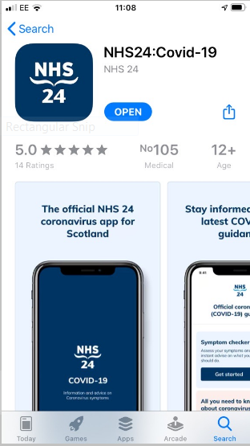

## Calling 111

The NHS is open for everyone during this pandemic. You should seek help for health concerns so we can offer the right treatment, in the right place, at the right time.

* Monday – Friday between 9am – 5pm, for health concerns for someone you are caring for that are **not** coronavirus/COVID-19 symptoms, you should call a GP as usual.
* For **coronavirus/COVID-19 symptoms** that are not a 999 call, you should call 111, during the day, at night and at weekends, and during public holidays.
* At night and weekends, and during public holidays, you should call 111 as usual for **all** health concerns.

## Accessible information

NHS 24 and NHS inform are here for everyone. We have information available in alternative formats on our website. There are commonly used languages, BSL, easy read and audio. There is information on some of the most frequently requested conditions as well as COVID-19. All alternative formats are on this page: [www.NHSinform.scot/translations](www.nhsinform.scot/translations). These can be used with people you care for, their family and friends.

## Anticipatory Care Planning (ACPs)

Anticipatory care planning is about conversations between patients, the people closest to them, and their care team. These conversations should be about their wishes for their health and wellbeing if they become unwell. People of all ages, who are living with a variety of health conditions, have ACPs.

**Making a plan helps people communicate what would matter to them if they fell ill during the COVID-19 pandemic.**

By having these conversations and making an ACP with health and care teams, people can make informed choices about the type of care they would like to receive if they need medical treatment during the COVID-19 pandemic. An ACP should be added to health records for use if someone becomes unwell.

[https://www.NHSinform.scot/illnesses-and-conditions/infections-and-poisoning/coronavirus-covid-19/coronavirus-covid-19-making-a-plan-for-your-care-during-the-covid-19-pandemic](https://www.nhsinform.scot/illnesses-and-conditions/infections-and-poisoning/coronavirus-covid-19/coronavirus-covid-19-making-a-plan-for-your-care-during-the-covid-19-pandemic)

Dr Paul Baughan, a GP in Forth Valley, and National Clinical Lead with Healthcare Improvement Scotland, has made this short video to explain the importance of care planning conversations for those most vulnerable to coronavirus infection.

<http://www.healthcareimprovementscotland.org/our_work/coronavirus_covid-19/care_planning_conversations.aspx>

## Registration of a death

Sadly, you may find that you are responsible for registering a death. From 25 March 2020, due to the social distancing requirements for coronavirus (COVID-19), the death registration process has changed. There are details on what you need to do here

* National Records of Scotland - registering a death during the COVID-19 pandemic. [www.nrscotland.gov.uk/registration/registration-services](http://www.nrscotland.gov.uk/registration/registration-services)

General advice on bereavement is available from NHS inform

* [www.NHSinform.scot/care-support-and-rights/death-and-bereavement](https://www.nhsinform.scot/care-support-and-rights/death-and-bereavement)

## Wellbeing for carers, families and friends

NHS inform has useful information to support us all with our emotional and mental health during the pandemic. [www.NHSinform.scot/coronavirus-mental-wellbeing](http://www.nhsinform.scot/coronavirus-mental-wellbeing)

clearyourhead.scot is a Scottish Government website with a range of ideas for taking care of yourself, and links to organisations and help lines that can offer support for emotional wellbeing.

There are further resources including information on managing personal or business difficulties and money worries from

* Ready Scotland [www.readyscotland.org/coronavirus/](http://www.readyscotland.org/coronavirus/)
* Citizen's Advice Scotland [www.cas.org.uk](http://www.cas.org.uk)

## Further resources

NHS inform has a wide range of health resources relating to COVID-19 for people in Scotland of all ages and with all kinds of concerns. Browse them here

* [https://www.NHSinform.scot/illnesses-and-conditions/infections-and-poisoning/coronavirus-covid-19](https://www.nhsinform.scot/illnesses-and-conditions/infections-and-poisoning/coronavirus-covid-19)