

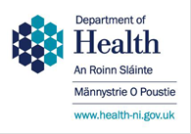

To: Directors of Nursing 1 May 2020

Dear nursing and midwifery colleagues,

We would like to express our immense gratitude to the nursing and midwifery workforce working in the NHS and social care. Over the past four months, the health system and its staff have been tested in a way no currently practising health professional has experienced. In the face of a new virus with many unknowns and the difficulties of PPE supply, you have risen to the challenge for your patients and the public and have done so with admirable determination, imagination, courage and flexibility.

The result of the work of the NHS and public health colleagues, along with nurses in the Care Home sector, an incredible collective effort combined with the remarkable support from the general public heeding the advice to stay at home unless necessary, means that the emergency capacity has not been overtopped at any stage in the first wave of the COVID-19 epidemic.

The way care has been provided has been changed as services have been reconfigured whilst many staff have been moved into different roles, and this has been central to our response. Some of these changes are actually improvements. Some inevitably have however led to a reduced capacity to provide non-emergency care and preventive services, and one of the indirect ways the COVID-19 epidemic will harm patients is through reducing our capacity to respond.

The devolved health administrations in association with the NHS have turned their attention to the process of planning for turning these services back on and this will help minimise the indirect harm of COVID-19. We need to do so in a way that acknowledges that this epidemic is far from over. While we are still seeing challenges with COVID-19 in our care home sector, we are coming past the first peak in our hospitals and communities due to collective efforts but the risk of further upswings in COVID-19 will be with us for the foreseeable future. We need to run as normal a health service as we can for our patients, whilst retaining the ability to move swiftly if we get further waves later in the year.

The nursing and midwifery professions have responded remarkably to this epidemic. You have our heartfelt gratitude on behalf of the professions, as well as the public.

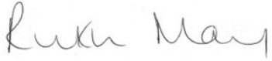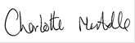
Ruth May Charlotte McArdle
Chief Nursing Officer, England Chief Nursing Officer, Northern Ireland

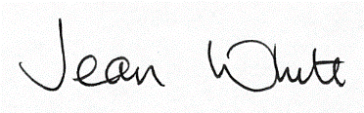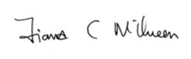
Jean White Fiona McQueen
Chief Nursing Officer, Wales Chief Nursing Officer, Scotland

