Human Rights Based Approach | Reasonable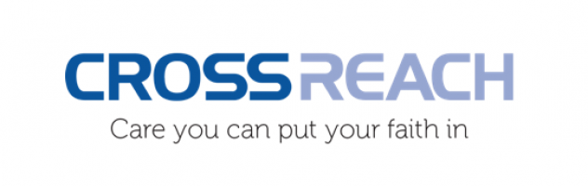 | Proportional | Justifiable
Stage 4, Locking of Residents Door, to ensure Self-isolation. | - During this national emergency, a protocol has been developed to assist with Service Users who due to their cognitive impairment are unable to adhere to the self-isolation required, if suspected or confirmed to have Covid-19. It is not a blanket protocol for people living within care homes with cognitive impairment. It has been created to ensure any restriction is appropriate and only applies when Service Users fit all 3 Criterions, which must apply at all times to the service user concerned.  - The Protocol attempts to manage this situation in the least restrictive way, maintaining the Service Users dignity, and supporting in a person centred way. This is achieved by looking in detail at their life history and interests. From this information the protocol attempts to engage the Service User in meaningful occupation.  - The protocol at every step attempts to use the least restrictive option. Where there has been the need to progress to stage 4, outside advice has been sought and safety measures have been actioned. Continuous assessment of criterions that applies are completed and where they no longer apply, the practice in Stage 4 ceases.  - The action of Stage 4 will only ever apply in the national emergency of Covid-19, and the aim of stage 4 is solely the to avoid the spread of Covid-19 thus saving lives while continuing to support the Service User concerned. | - There are 3 Stages prior to Stage 4. Where all attempts will be made to manage self-isolation, in a less restrictive way have been exhausted.  - Where Stage 4 has to be applied, Stage 4 is monitored continually and where any of the 3 Criterions do not apply at any stage the practice will be stopped.  - The risk to others living within the care home, many of whom are in the very vulnerable group is too great. There is the need to enforce self-isolation to save lives. However while in Self-Isolation staff will continue to meet the needs of the Service User.  - Stage 4 is in preference to chemical restraint which would be seen as a more detrimental to the physical health of a Service User who is already unwell. | - In all stages of this Protocol the rights of the person living with a cognitive impairment have been maintained.  - Requests for a Covid-19 test has been made, and further stages of this protocol only apply, if the request for a test has been refused or have returned a positive result.  - The Self-Isolation would only apply for the 7 days as indicated or when the person has recovered. It will be assessed continually and cease if Criterions no longer apply.  - Before Stage 4 advice is sought from outside bodies.  - All appropriate documentation will be completed and actions will be transparent.  - The protocol only applies during this national emergency and its sole purpose is to save lives, while supporting the Service Users concerned.

