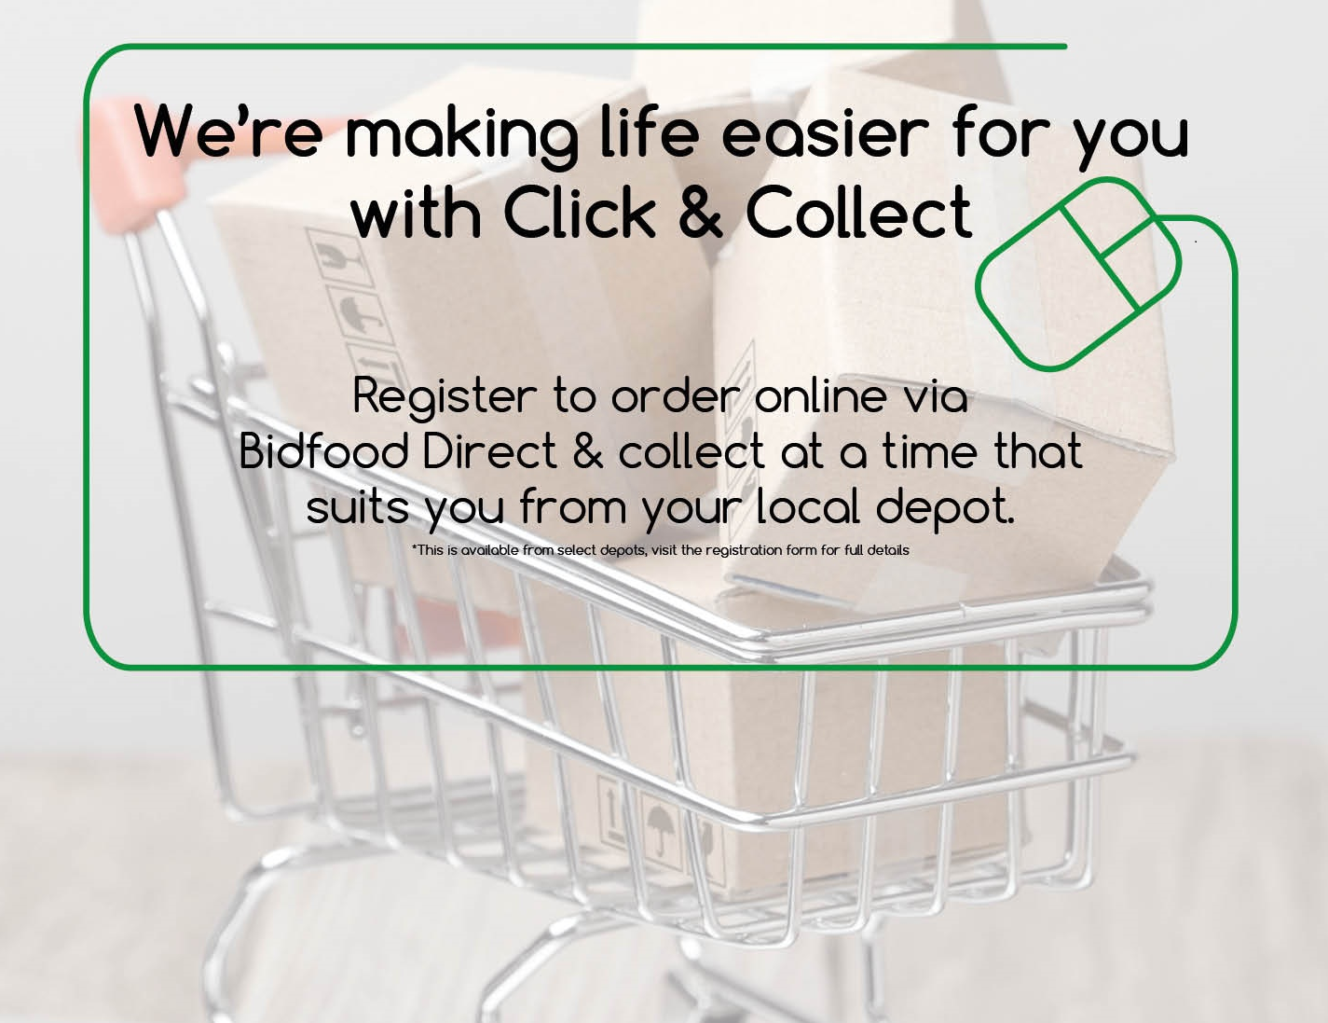

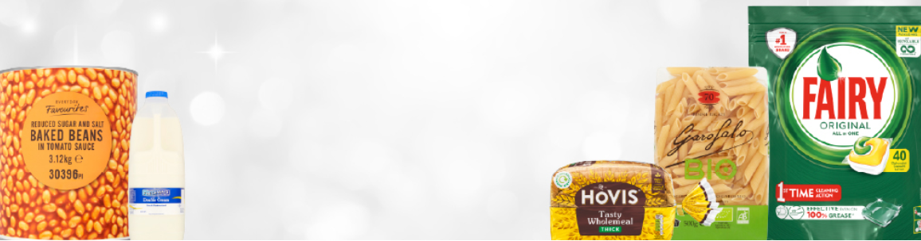



We are now offering a click & collect service via our Edinburgh Newbridge Depot to the public as well as deliveries to businesses.

We have a wide range of grocery, frozen, paper products, chemicals and chilled products, including fresh meat.

You can place your order for next day collection - Monday to Friday.

Our stock system is live which means you can see what we have in stock and collect what you have ordered!

Registration here on the link:

<https://www.bidfood.co.uk/become-a-customer/>

If you have any questions please get in touch.

**Sarah Gillespie & Claire O’Rourke**

BusinessManager [sarahgillespie@bidfood.co.uk](mailto:sarahgillespie@bidfood.co.uk) [ClaireORourke@bidfood.co.uk](mailto:ClaireORourke@bidfood.co.uk)

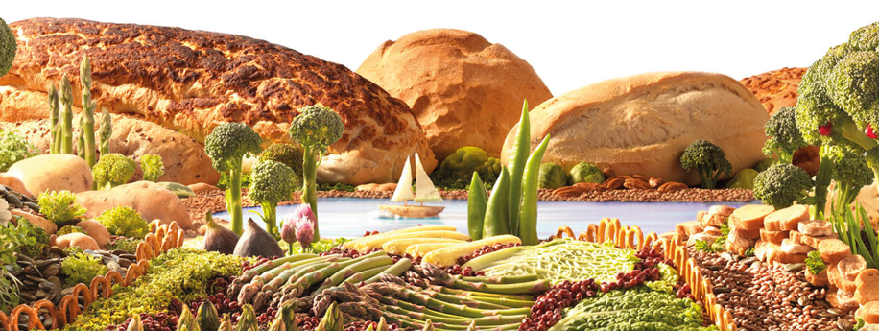*Bidfood Scotland, Junction 2 Industrial Estate, Claylands Rd, New Bridge, EH28 8LF*